Enhancing Performance Of Operating System Using Machine Learning

(Mid Term Report)



Project Members:
1. Lakshay Bansal (287/CO/12)
2. Ravish Mahur (339/CO/12)
3. Rishab Banerjee (340/CO/12)

CONTENTS
- ABSTRACT………………………………………………………………….3
- WORK HITHERTO
2.1 Courses Pursued…………………………………………………...……4
2.2 Research Papers Referred……………………………………..………4
3. VARIOUS MACHINE LEARNING ALGORITHMS

3.1 Linear Regression……………………………………………..…….……6

3.2 Logistic Regression………………………………………….…..............7

3.3 Neural Networks…………………………...…………..………………….8

3.4 K-Means ………...................…………………………......……………...9

4. FOCUS AREAS OF OS
4.1 Process Scheduling........................................................................11
4.2 Memory Management.....................................................................12
4.3 Disk Scheduling..............................................................................14

5. SUMMARY…………………………………………………....…………..........19

ABSTRACT
There is no single scheduling or memory management algorithm that could provide good performance consistently under varying environment – Being affected by workload(type and size of Program/data), file system, disk system.
Therefore, a new self learning approach is proposed which can adapt to various types of workloads, and make decisions for optimizing the performance of the Operating System.

WORK HITHERTO

Courses Pursued :
- Machine Learning (Dr. Andrew Ng, Stanford University)

- Introduction To Data Science (Dr. Bill Howe, Washington University)
- Artificial Intelligence(UC Berkeley)
- R Programming (Dr. Roger Peng, John Hopkins )
- Introduction To Linux (edX)

Research Papers Read:
- Self Learning Disk Scheduling (IEEE)
- Applying Machine Learning Techniques to improve Linux Process Scheduling (IEEE)
- To Collect Or Not to Collect? Machine Learning For Memory Management ()
- Dynamic Multicore Resource Management: A Machine Learning Approach

VARIOUS MACHINE LEARNING ALGORITHMS
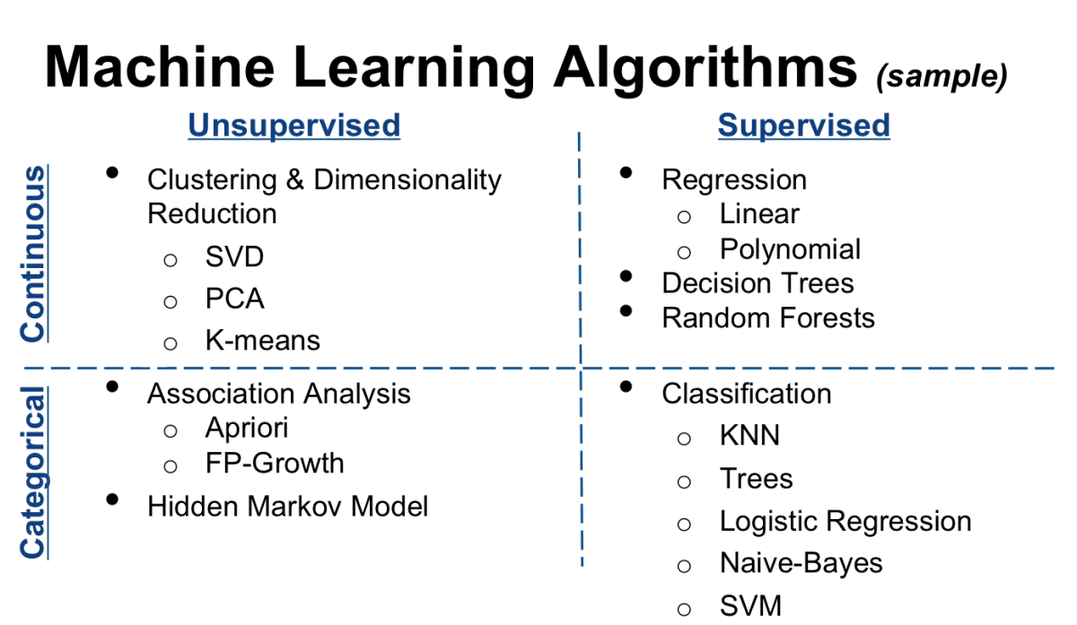

LINEAR REGRESSION
- Regression is used to predict scalar (continuous) values given some inputs.
- A cost function ,called "Squared error function" is used to find the accuracy of the hypothesis function.
- Gradient Descent or Normal Equation can be used to find the values of parameters (theta 1 and theta 2) that minimize the cost function.
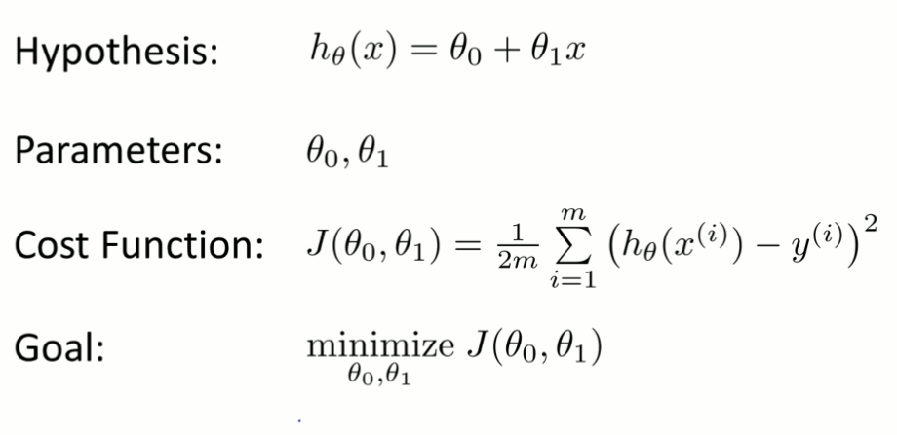

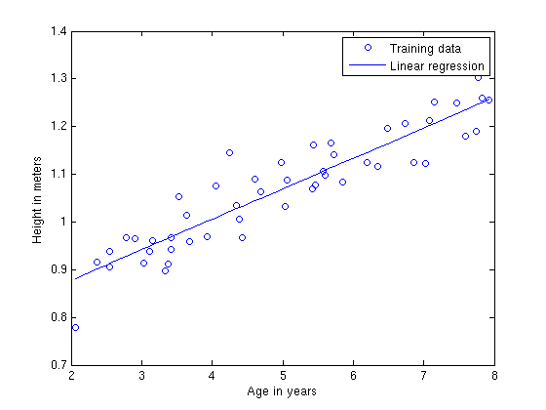

LOGISTIC REGRESSION

- Is a statistical classification model

- Predicts binary response from a binary predictor for predicting the outcome of a categorical dependent variable
- Applications :
  - Predict whether a voter will vote for Congress or BJP based on age, income, gender, caste etc
  - Predict whether a tumour is malignant or benign
  - Whether a job is IO bound or CPU bound

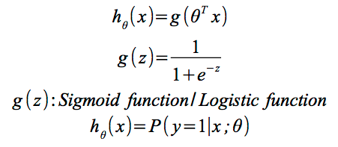

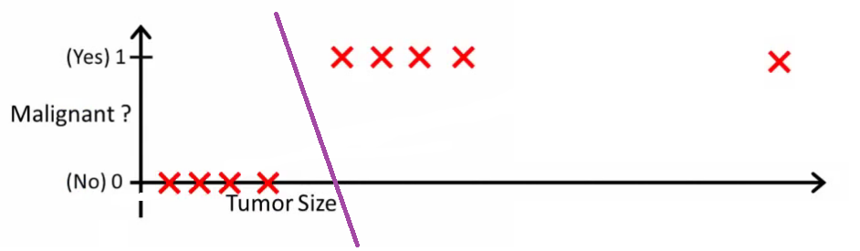

Neural Networks
In order to model any complex non linear hypothesis as shown, higher order polynomials may be required. As the degree of the polynomial increases it becomes computationally expensive to calculate the values. Neural networks come handy in such situations.

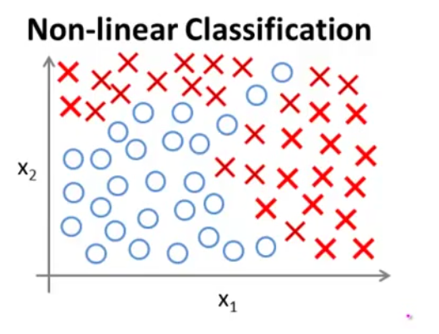

Instead of calculating the features at one go, the work is divided into steps. The neurons mimic the human neurons. Every node acts as a neuron, it takes input from one or more nodes and does some processing and passes the processed data to the connected nodes in the next level. The nodes are partitioned into layers with output of nodes at layer i-1 feeding nodes at i. The user only has to interact with the input and output layer. The intermediate layers stay hidden from the user. The parameters are called weights. Biasing inputs may be applied to a neuron.

K-Means

The K-means algorithm: a heuristic method
K-means algorithm (MacQueen’67): each cluster is represented by the centre of the cluster and the algorithm converges to stable centriods of clusters.
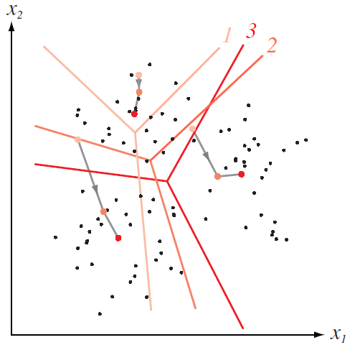
K-means algorithm is the simplest partitioning method for clustering analysis and widely used in data mining applications.

Given the cluster number K , the K-means algorithm is carried out in three steps after initialization:

Algorithm:
Initialization: set seed points (randomly)
1. Assign each object to the cluster of the nearest seed point measured with a specific distance metric

2. Compute new seed points as the centroids of the clusters of the current partition (the centroid is the center, i.e., mean point, of the cluster)

3. Go back to Step 1, stop when no more new assignment (i.e., membership in each cluster no longer changes)

FOCUS AREAS OF OS

Optimize the performance of the following aspects of OS:

- Process Scheduling
- Memory Management
- Disk Scheduling
- Cache Replacement
etc...

PROCESS SCHEDULING

Intuition
Generally process schedulers allocate CPU time slices to a process according to a scheduling algorithm that does not use any previous execution history of the process. It might be possible to better utilize resources if we could “recognize” a program and predict its resource requirements.
Historically In the paper by Smith et al. the authors predicted the application run times using historical information. They present a technique for deriving predictions for the run times of parallel applications from the run times of similar applications that have executed in the past. They use the following characteristics to define similarity: user, queue, load leveler script, arguments, network adapter, number of nodes, maximum run time, submission time, start time, run time. These characteristics are used to make a template which can find the similarity by matching. They use genetic algorithms for identifying ”good templates” for a particular workload. A template defines the similarity between two applications. They use Genetic Algorithm (GA) techniques to determine those application characteristics that yield the best definition of similarity for making predictions. However from a machine learning perspective, Gas are expensive in terms of computation [15] and also thei r results are considered fragile.
Approach followed (in the research paper read):
Predictive scheduling based on decision trees using static and dynamic attributes (size of program, data size, type of imput etc) reduced the TaT by about 6%. This was due to a reduction in the number of context switches needed to complete the process execution.
Modifications/ Improvements Possible:
Application of other techniques like neural networks and comparison of the overheads and performance and find the best possible alternative.

MEMORY MANANGEMENT
Intuition
Garbage Collection is a very important part of the modern day systems. As the pointer and variable sizes increases, there is also a corresponding increase in the processes and thus there is immense load on the OS to free up as much memory as possible.
Most garbage collectors like parallel garbage collection and stop-and-copy start the garbage collection process only after the heap becomes full. A full heap would cause all application threads to stop, which would not be necessary if some kind of concurrent garbage collection had started in time.
Approach Planned (in the research paper read):
Reinforcement learning provides an approach in which an agent interacts with the environment and learns by trial and error rather than from direct training examples. Providing startup parameters for controlling the rule heuristics is a good start but it cannot adapt over time to a dynamic environment that has different needs at different points of time. The idea is to let a learning decision process decide which garbage collector technique to use and how to use it, instead of static rules making these decisions during run time.
Reinforcement learning methods solve a class of problems known as Markov Decision Processes (MDP). If it is possible to formulate the problem at hand as an MDP, reinforcement learning provides a suitable approach to its solution
Formal Processes Followed:
A policy is a mapping from states to actions π: SxA → [0, 1], in which π(s, a) denotes the probability with which the agent chooses action a in state s. As a result of the action taken by the agent in the previous state, the environment transitions to a new state s(t+1). Depending on the new state and the previous action the environment might pay a reward to the agent. The scalar reward signal indicates how well the agent is doing with respect to the task at hand. However, reward for desirable actions might be delayed, leaving the agent with the temporal credit assignment problem of figuring out which actions lead to desirable states of high rewards. The objective for the agent is to choose those actions that maximize the sum of future discounted rewards: R = r t + γ r t+1 + γ 2 r t+2 .... The discount factor γ∈[0,1] favors immediate rewards over equally large payoffs to be obtained in the future. In the general case the system behavior is determined by the transition probabilities P(s t+1 | s t , a t ) for ending up in state s t+1 if the agent takes action a t in state s t and the reward probabilities P(r | s t , a t ) for obtaining reward r for the state action pair s t , a t. A state signal that succeeds in retaining all relevant information about the environment is said to have the Markov property. In other words, in an MDP the probability of the next state of the environment only depends on the current state and the action chosen by the agent, and does not depend on the previous history of the system.

DISK SCHEDULING

- The performance of disk I/O schedulers is affected by many factors such as workloads, file systems, and disk systems. Disk scheduling performance can be improved by tuning scheduler parameters such as the length of read timers. Scheduler performance tuning is mostly done manually.
- To automate this process, we propose four self-learning disk scheduling schemes:
Change-sensing Round-Robin, Feedback Learning, Per-request Learning, and Two-layer Learning.
- Experiments show that the novel Two-layer Learning Scheme performs best. It integrates the workload-level and request-level learning algorithms. It employs feedback learning techniques to analyze workloads, change scheduling policy, and tune scheduling parameters automatically.
- We discuss schemes to choose features for workload learning, divide and recognize workloads, generate training data, and integrate machine
learning algorithms into the Two-layer Learning Scheme.
- We conducted experiments to compare the accuracy, performance, and overhead of five machine learning algorithms: decision tree, logistic regression, naı¨ve Bayes, neural network, and support vector machine algorithms.
- Experiments with real-world and synthetic workloads show that self-learning disk scheduling can adapt to a wide variety of workloads, file systems, disk systems, and user preferences. It outperforms existing disk schedulers by as much as 15.8 percent while consuming less than 3 percent - 5 percent of CPU time.

Change-Sensing Round-Robin Selection

- The self-learning core in the operating system invokes all schedulers in a round-robin fashion
- Phases
–Phase 1: Selection phase
–Phase 2: Execution phase

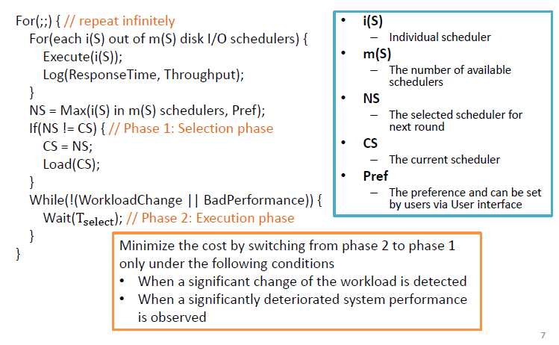

Feedback Learning

- The round-robin execution and switching are moved offline
- Phase
–Phase 1: Training phase
–Phase 2: Decision phase
–Phase 3: Feedback phase

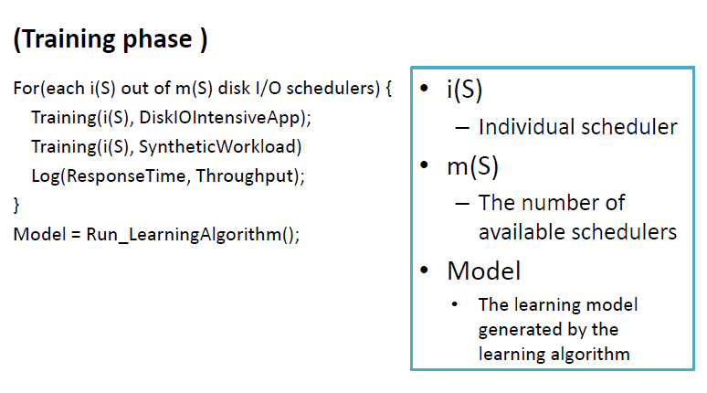
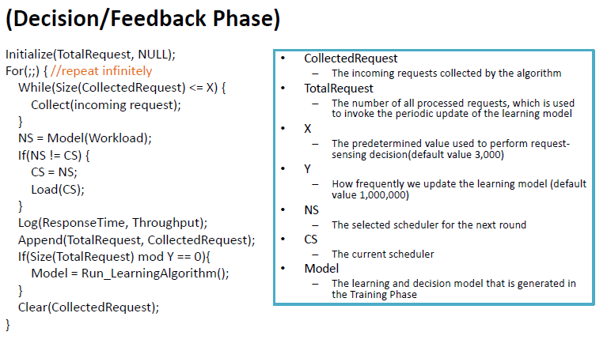

Per-Request Disk I/O Schedular

- The self-learning scheduler makes scheduling decisions at the request level instead of the workload level
- No longer log or compare the performance of the existing scheduling policies
- Phase
–Phase 1: Training phase
–Phase 2: Decision phase
–Phase 3: Feedback phase

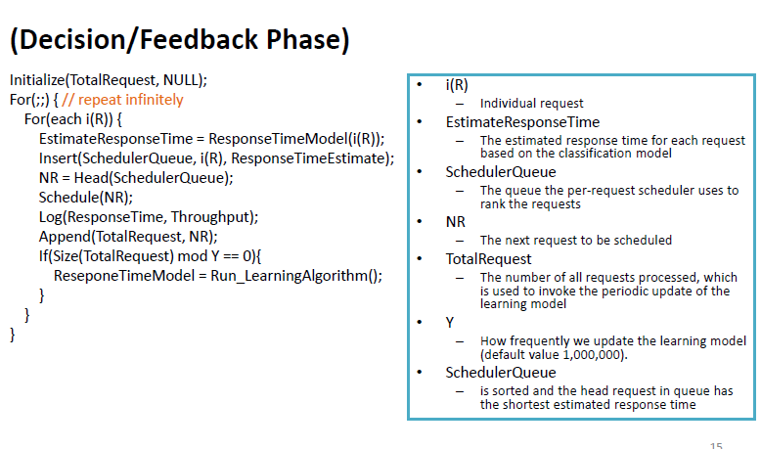

Two-Layer Combined Learning Scheduler

- Phase 1: Training phase
–Step
1. Train the per-request decision scheduler by the methods in Algorithm 3
2. Train the scheduling scheme that consists of traditional schedulers plus per-request decision scheduler by the training procedures for Algorithm 2

- Phase 2: Decision phase / Phase 3: Feedback phase
• Remain mostly unchanged, except that the per-request decision scheduler becomes one of the possible schedulers

Potential Machine Learning Algorithms
- C4.5 decision tree algorithm
–C4.5 generates a decision tree, which is a classifier in the form of a tree structure, based on the ID3 algorithm
- Logistic regression
–Logistic regression is a regression method for Bernoulli-distributed dependent variables that utilizes a logistic function as the link function
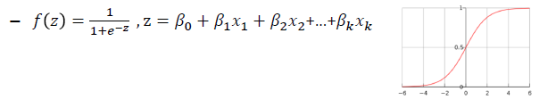

- Naïve Bayes
–The Naïve Bayes classifier applies Bayes' theorem with Naïve independence assumptions

- Neural networks
–The neural network (NN) is an adaptive system that adapts itself based on external or internal information that travels through the network

- SVM(Support Vector Machine)
–The SVM algorithm maps input vectors to a higher dimensional space

